

Shopping simulating system

Software Design Specification



December 14, 2016

Huizhe Wang

NUID: 001614841

Contents

Introduction 2

System Overview 2

Definitions, Abbreviation and References 3

Design Considerations 4

Assumptions 4

Constraints 5

System Environment 5

Design Methodology 5

Architectural (High-level) Design 5

Overview 5

Frame 6

Server 7

Low Level Design 8

Server (Spring Web for Users) 8

Client (for Users) 8

EER 9

Client (Visitor, User and Admin) 10

Sign up/in 10

Admin 11

Users 12

User Interface Design (Support Information) 13

# Introduction

## System Overview

This Shopping Simulating System serves as an aid for admin to collect the users’ orders. It is free even though the customers make orders.

In the System, the product information will be presented in the users’ screen by admin. Users could search these products by category and second category, search them by keywords, and then add the products, make their orders. Moreover, users could give admin comments whatever they want to say. For Admin, the main function of the Shopping Simulating System is management, like manage users, products, orders, comments and the categories.

The benefits of the Shopping Simulating System will be far-reaching. The records of users’ orders and comments could be analyzed by admins and help them grasp the majority users demand. For Users, they could enjoy shopping and to be hip to the latest styles without pay money.

# Definitions, Abbreviation and References

*Definition and Abbreviation*

1. SSS: Shopping Simulating System – the software application that is being discussed in this design specification.
2. MVC: Model-View-Controller – a software design pattern for implementing user interfaces on computers.
3. DAO: Data Access Object – an object that provides an abstract interface to some type of database or other persistence mechanism.
4. WWW: World Wide Web: a collection of hyper text documents accessed via the Internet.
5. JEE: Java Enterprise Edition: a widely used platform for server programming in the Java programming language.
6. Java: a system for developing cross-platform application software.
7. HTTP Sessions: allow associating information with individual visitors.

*References (3rd party Frameworks)*

1. Eclipse: <https://eclipse.org/downloads/>
2. Spring: <http://www.springsource.org/about>
3. Spring Security: <http://projects.spring.io/spring-security/>
4. Hibernate: <http://hibernate.org/>
5. MySQL: <http://www.mysql.com/>
6. CSS Framework: <http://purecss.io/>
7. xhEditor: [https://](NULL)[github.com/yaniswang/xhEditor](https://github.com/yaniswang/xhEditor)
8. Treehouse: [https://github.com/ErikGartner/dTree](http://projects.spring.io/spring-security/)
9. JQuery: <http://api.jquery.com/>
10. Tomcat: <http://tomcat.apache.org/>

# Design Considerations

## Assumptions

The operational environment required for the SSS is a Spring Source server such as Tomcat Server. The database of the SSS client is MySQL. The SSS is independent and not a component of a larger system.

## Constraints

Certain data constraints should be in effect since excessive data transmission with photos would reduce operating speed.

## System Environment

The software that the Shopping Simulating System server will run on is the Java Application Server Tomcat 8.0.

Integral to the operation of the Shopping Simulating System are certain services that manage data and business logic. These services that the SSS interacts with are some fashion web, likes [BAZZAR](http://www.harpersbazaar.com/), [VOGUE](http://www.vogue.com/magazine/), [ELLE](http://www.elle.com/) and so on.

## Design Methodology

The design methodology being employed here is the UML object-oriented technique insofar as necessary since large parts of the SSS functionality are implemented by 3rd party services that have been designed and implemented already.

# Architectural (High-level) Design

## Overview

The SSS client will run on website. The SSS server application is a Spring MVC JEE-based web application that runs within the Tomcat 8.0. It consists of Spring controllers that respond to requests for data from the SSS client and Spring views that present the model as the response to the client requests. These controllers/views manage the requested data.

## Frame

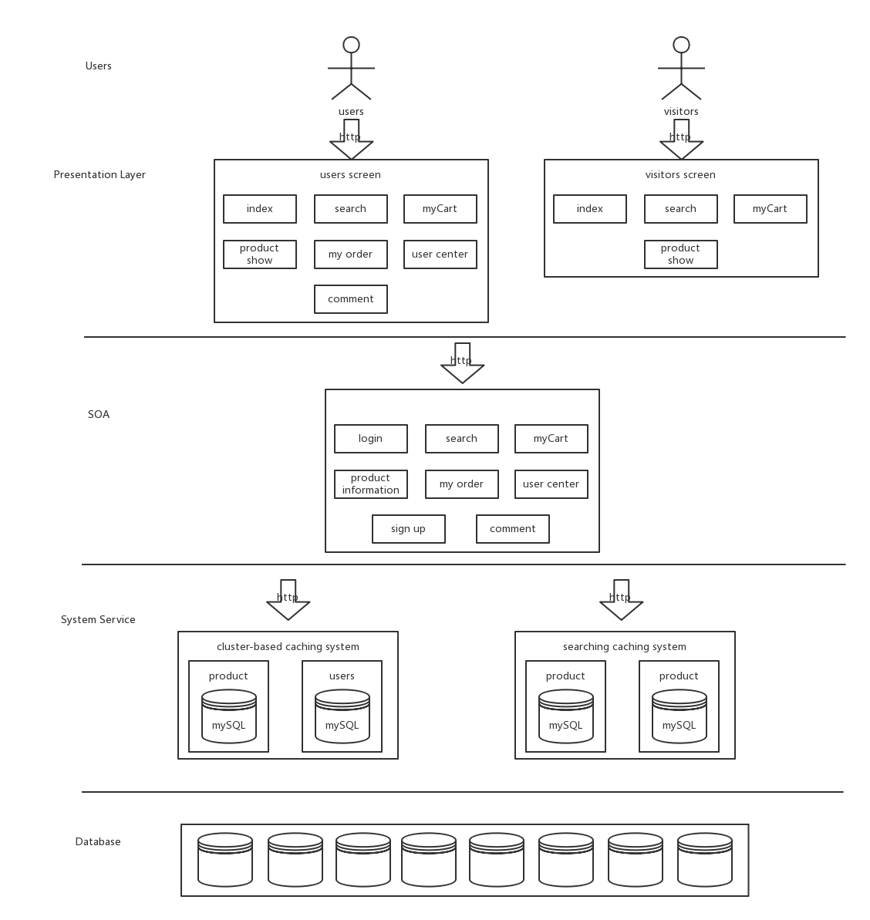

## Server

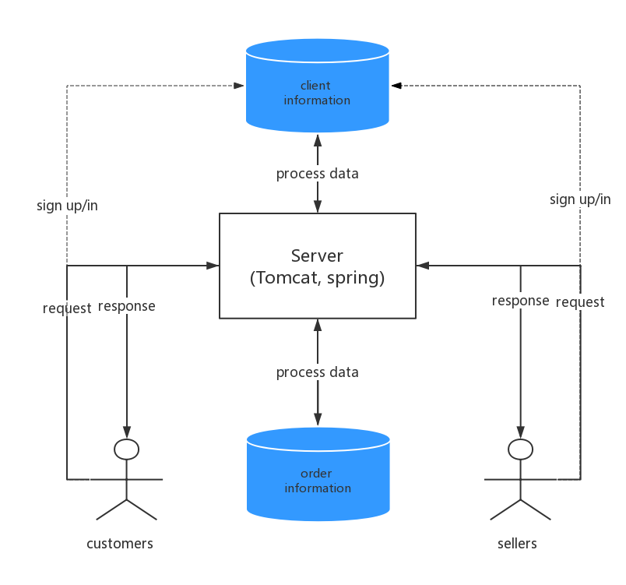

# Low Level Design

## Server (Spring Web for Users)

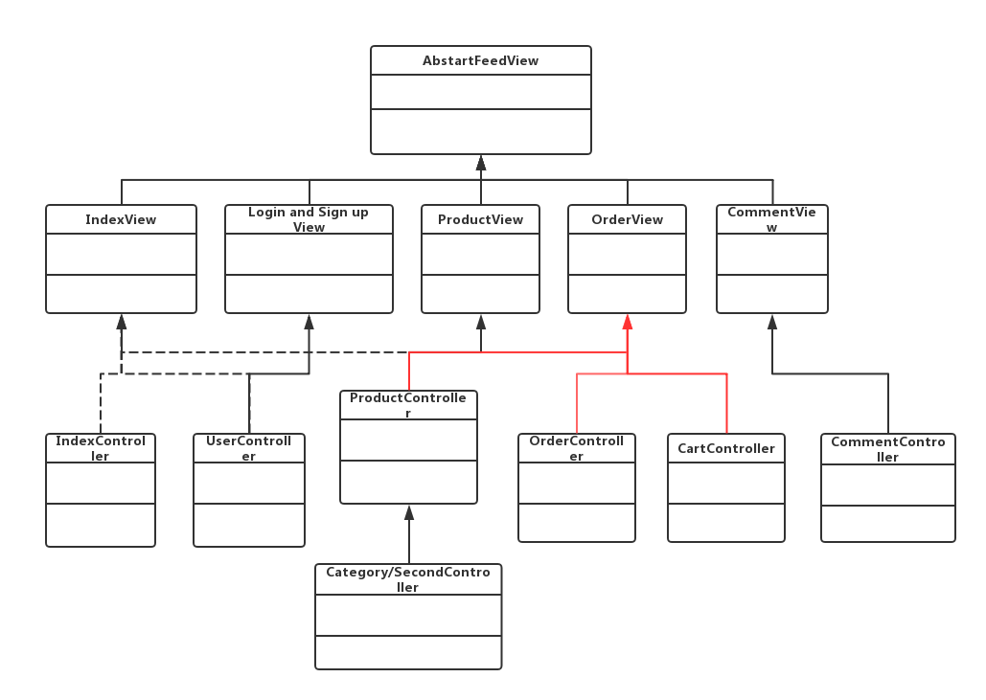

## Client (for Users)

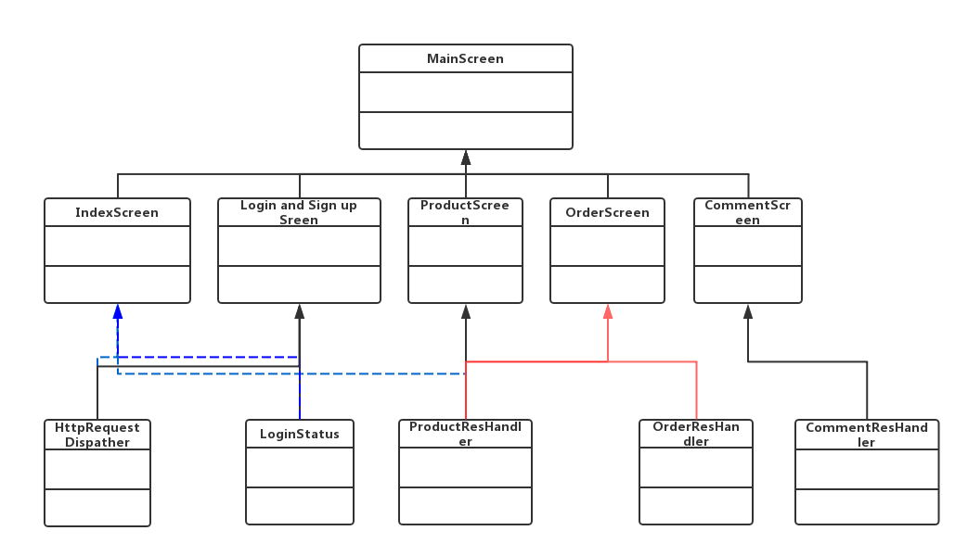

## EER

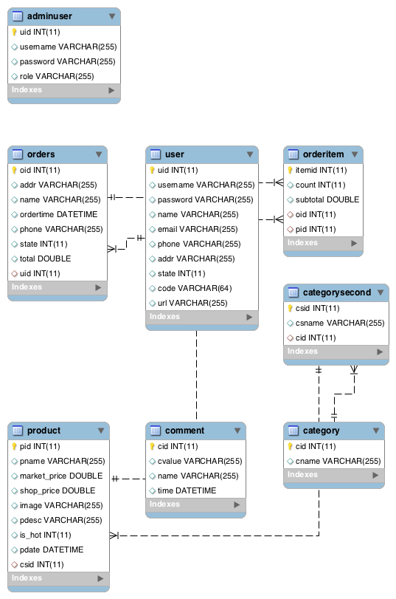

database implementation

# Client (Visitor, User and Admin)

Shopping Simulating System for users and admin:

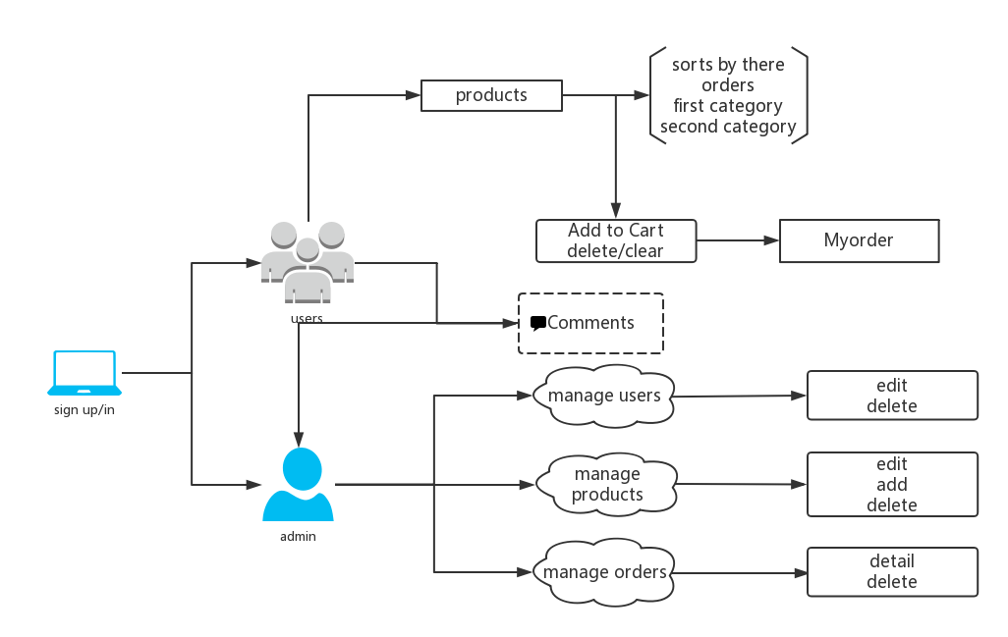

use case diagram

## Sign up/in

1. **Introduction:** the SSS allows the customers and sellers to access the different web pages. The database which storing users’ information is different from the product one. When users sign up, the database will store their usernames and passwords. When users sign in, the database will judge whether their usernames and passwords match or not. Moreover, users could reset when they sign up/in, and change their passwords.
2. **Inputs:** Users will have authenticated to the SSS server and send their requests.
3. **Outputs:** The server will deal with their request and send them to the right pages. Customers has no right to enter into sellers’ pages, and vice versa.

## Admin

### view/sort products

1. **Introduction:** The SSS allows customers view details of products and sorts products with department, price, or arrival time.
2. **Inputs:** user input is available if customers want to search the products they want to see. However, in most case, they would choose to select the options given by sellers.
3. **Outputs:** Visible output on the screen will consist of the details of the products selected along with any additional requests, such as “the price from 50 dollars to 200 dollars”.

### create/delete orders

1. **Introduction:** The SSS allows the customers work with his or her own orders. An appropriate form will be presented to the customers so that he or she can create orders. Moreover, an appropriate option will also be presented so that customers want to delete their orders. Deleting a calendar event will delete the information stored in the database.
2. **Inputs:** No user input is required other than the selection of the product information given by sellers, such as the size, order number and color of clothes.
3. **Outputs:** Only visible output on the screen would be a confirmation message that the orders have been created or deleted.

### Manage comments

### Manage users

## Users

### manage products

1. **Introduction:** The SSS allows the sellers to upload, add, change and delete the product information which will display on the customers’ screen.
2. **Inputs:** User input is available if sellers want to add some information the web developer doesn’t give. However, in most case, they would choose to select the options given by the manager, such as the arrival time, price, color and department.
3. **Outputs:** The uploaded, added and updated information would be displayed on the screen. Only visible output on the screen would be a confirmation message that some products have been deleted.

### manage orders

1. **Introduction:** The SSS allows the sellers to view customers’ orders directly. Sellers could sort the orders by time or number. Moreover, sellers could delete customers’ order with sending an email to that customer.
2. **Inputs:** The user must provide the information that he or she wants to delete customers’ orders.
3. **Outputs:** With sending an email to customers, only visible output on the screen would be a confirmation message that the customers’ orders have been deleted.

### Give Comments

1. **Introduction:** The SSS allows all the users to write comments to admin as long as they have signed up/in.
2. **Inputs:** Users input is necessary. An appropriate form will be presented to the users so that he or she could leave their words in the message, which would be viewed by admin.
3. **Outputs:** The comments will be sent to admin.

# User Interface Design (Support Information)

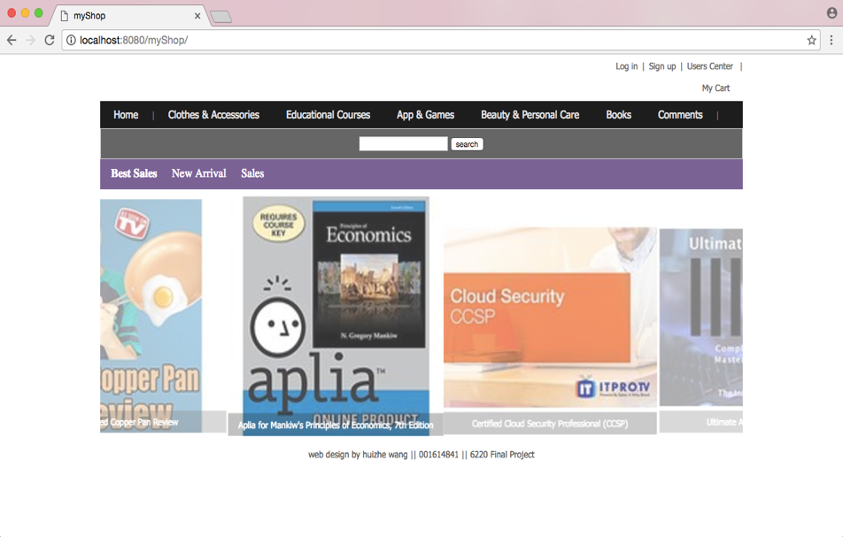

home page for users

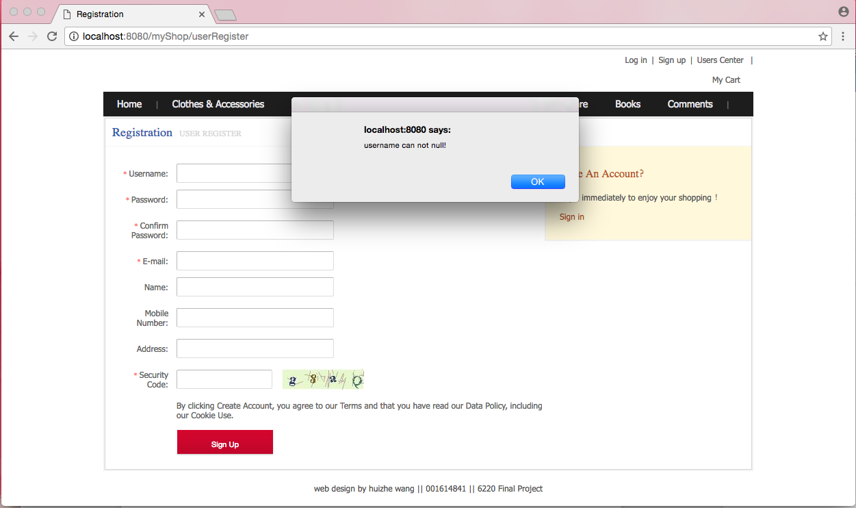

sign up for users

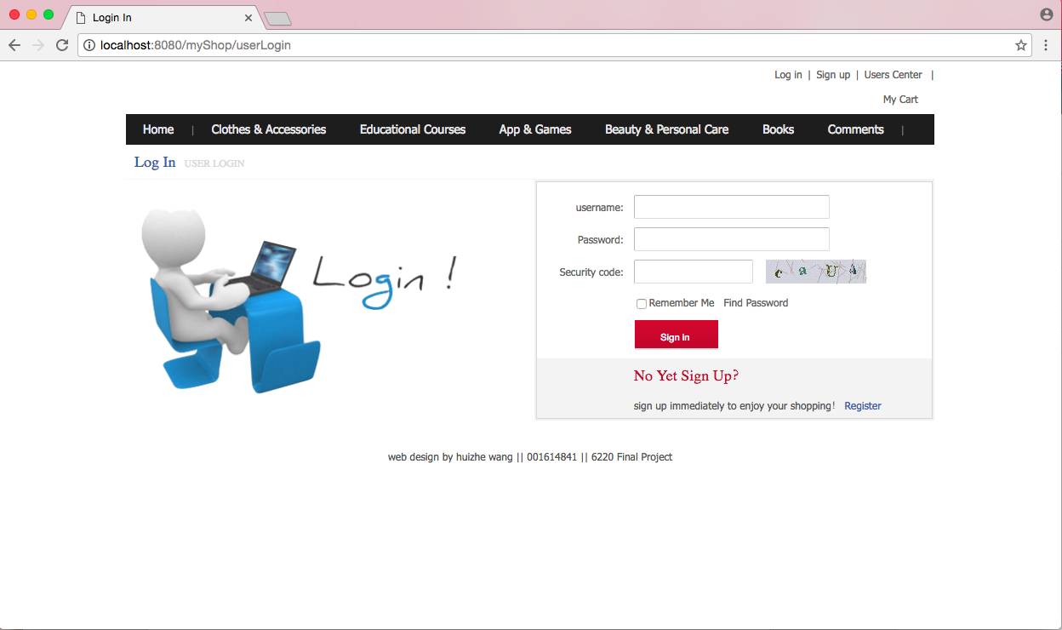

sign in for users

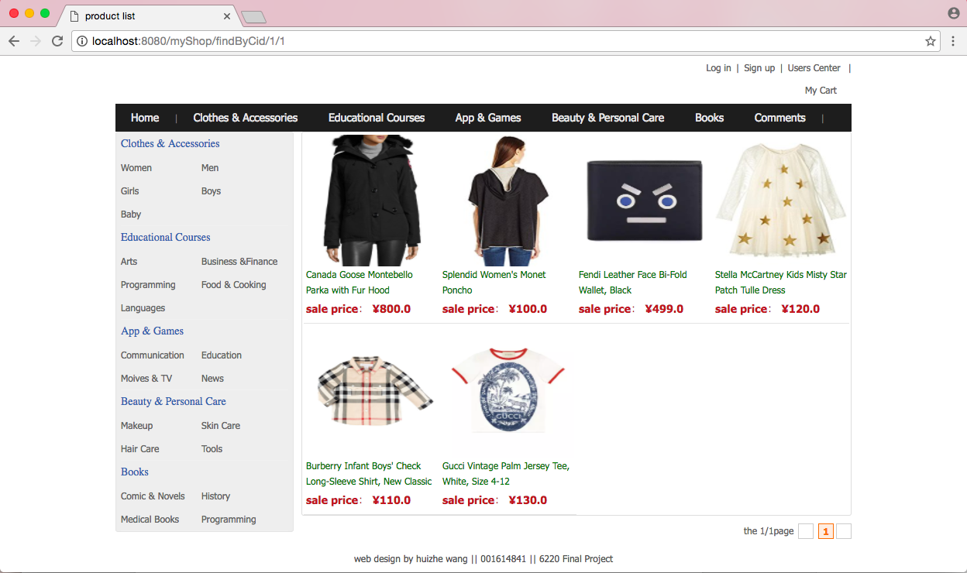

product lists

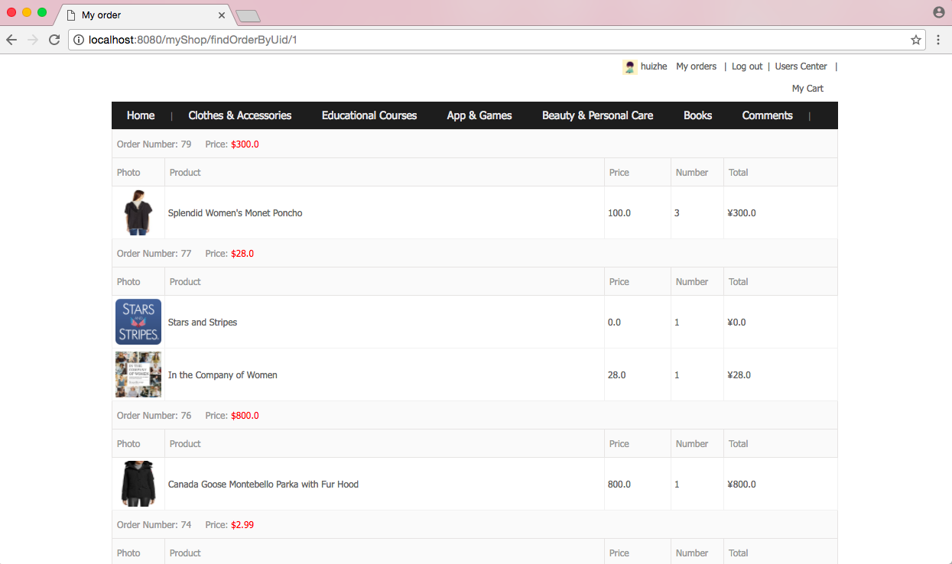

my orders (after sign in)

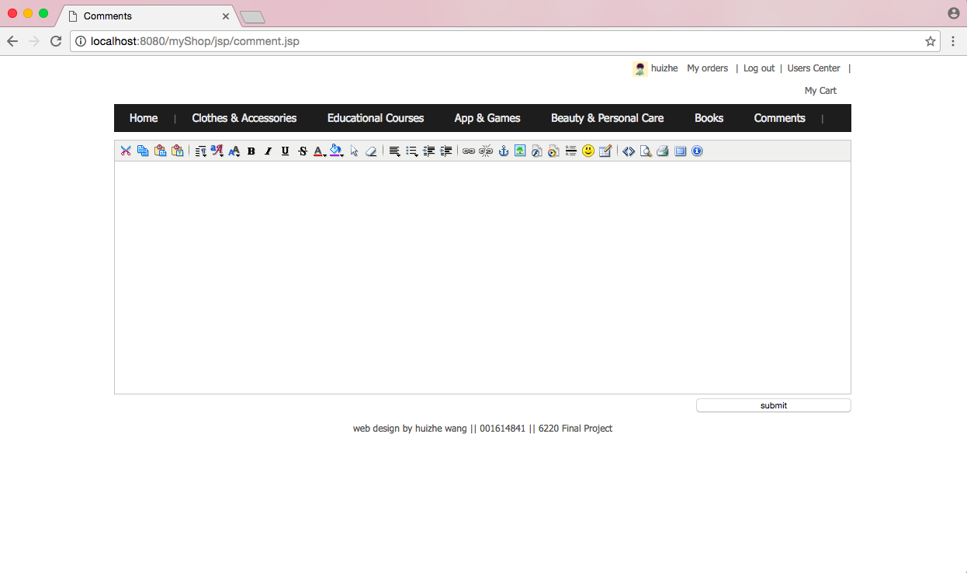

comments

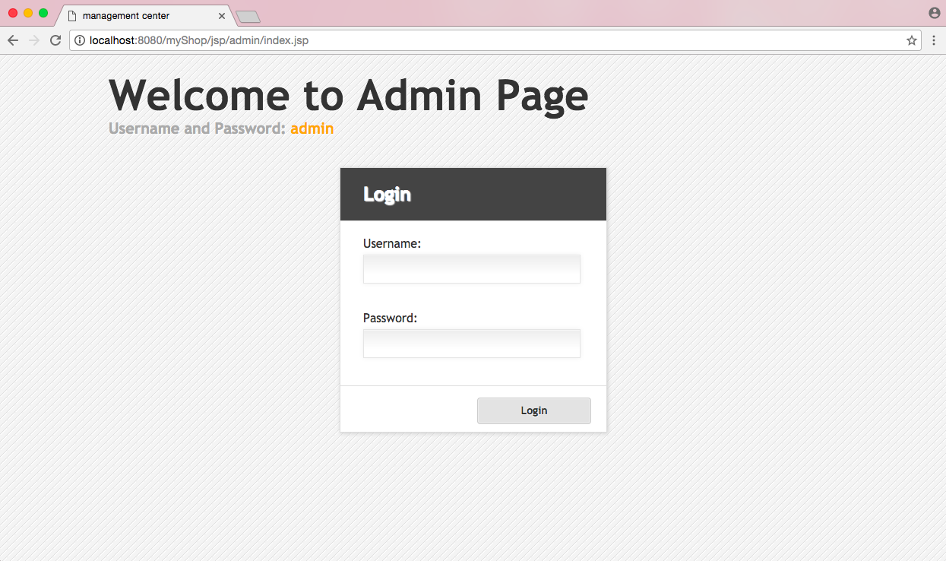

sign in for admin

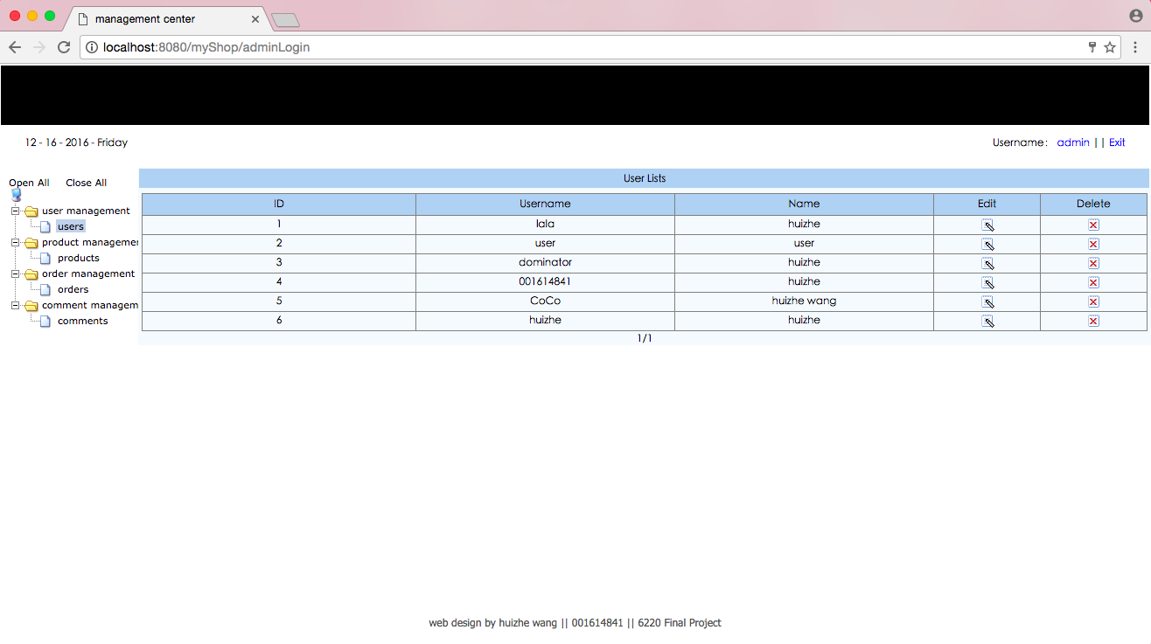

user lists

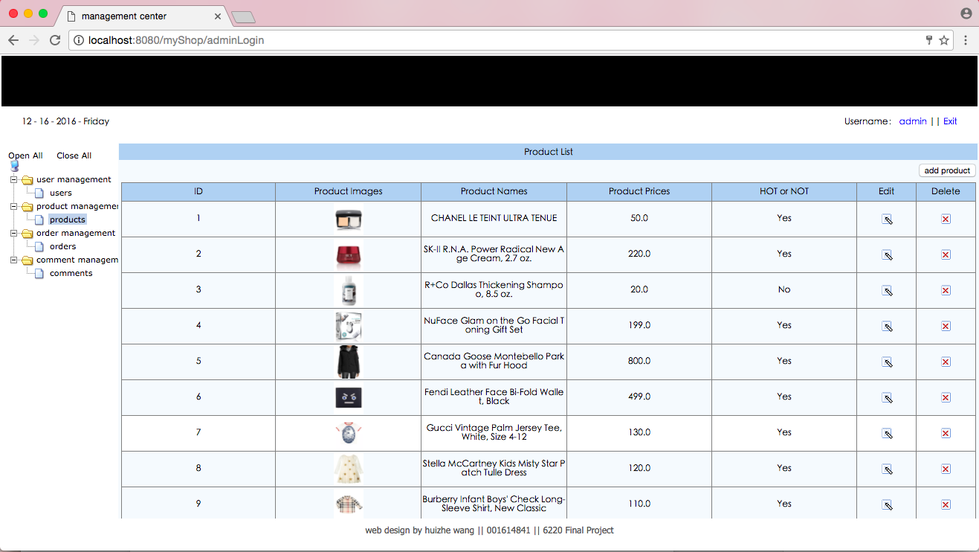

product lists

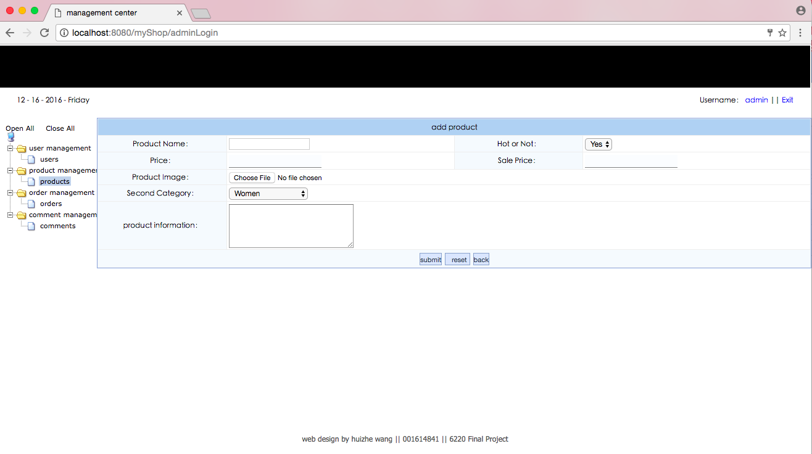

add product